BRESH Hosts the Most Exclusive Latin Grammy Afterparty in Las Vegas

The “most beautiful party in the world” made history once again—this time in Las Vegas—with an official afterparty that became the epicenter of celebration following the 2025 Latin Grammy Awards. BRESH, the global phenomenon that has redefined nightlife culture, brought together artists, producers, and celebrities from across Latin America at one of the most talked-about events of the year.
Among the attendees were Rauw Alejandro, Maluma, and Arcángel, as well as Ca7riel and Paco Amoroso, who celebrated the night as recent Latin Grammy winners. The party was a perfect blend of good vibes, music, and unique moments that defined the early hours of the Las Vegas night.
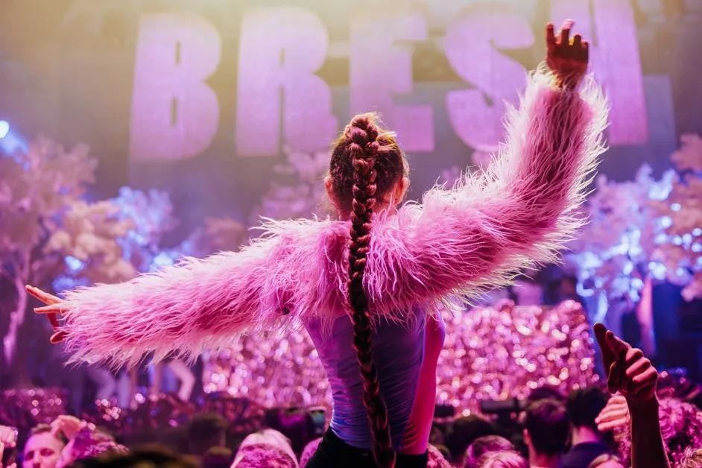
During the evening, Luck Ra performed his hit “La Morocha,” one of the songs that has dominated the year, while Alleh and Yorghaki surprised the audience by taking the stage to dance and perform their track “Merenguetón.”
Another special moment came when Maluma, from his table and without a microphone, sang his iconic “Hawái,” sparking an ovation from everyone present. There were also scenes of connection between artists and fans, with the dance floor filled with figures from the urban and Latin music scene, all celebrating to the rhythm of Pedro Sampaio’s DJ set, which kept the energy high throughout the night.
This afterparty marks the fifth consecutive year that BRESH has hosted the official celebration following the Latin Grammy Awards—a tradition that began in 2021, with three editions held in Las Vegas in collaboration with Sony Music, solidifying a key partnership between the two brands.

